SOFTWARE ENGINEERING PROJECT REPORT
Mid-Term Submission — 50% Implementation Review
Project Title: StudyFlow — An AI-Powered Adaptive Study Management Platform

1. Problem Statement
In contemporary academic environments, students are faced with the challenge of managing multiple subjects simultaneously while attempting to maintain consistent study habits, track their progress, and comprehend complex academic materials. The absence of an integrated digital solution that combines time tracking, intelligent note-taking, content analysis, and AI-driven coaching forces students to rely on fragmented, disjointed tools — separate timers, paper notes, PDF readers, and passive study schedules — none of which communicate with one another or adapt to individual learning patterns.
Existing productivity applications such as Notion, Toggl, or Anki each address only a narrow slice of the student's study workflow. They lack: (a) real-time intelligent analysis of study behaviour, (b) AI-assisted note generation and contextual question answering within a unified editor, (c) document-level knowledge extraction and prerequisite mapping, and (d) personalised coaching based on actual study data. This fragmentation leads to poor self-regulation, uneven subject coverage, and inefficient study sessions.
The core software engineering problem can therefore be stated as: the need to design, architect, and implement a full-stack, cloud-native web application that unifies study session management, AI-enhanced note-taking, document intelligence, and analytics into a single cohesive platform — built using modern software engineering principles including modular component design, event-driven real-time data synchronisation, RESTful API integration, and scalable backend services.

2. Objectives
The following objectives have been defined in accordance with IEEE 830 Software Requirements Specification (SRS) guidelines, classified into functional and non-functional categories:
2.1 Functional Objectives
- Timer & Session Management: Design and implement a precise focus-session timer with start, pause, resume, and stop operations, persisted via an event-sourcing pattern to a PostgreSQL backend (Supabase). The system must derive session state from a sequence of immutable focus events.
- Subject-Wise Analytics Dashboard: Develop a real-time analytics module that aggregates time-series data and renders visualisations (area charts, pie charts, heatmap calendars) for daily, weekly, and monthly productivity views. A computed productivity score must be derived from multi-variable weighting.
- AI Study Coach: Integrate a conversational AI assistant (Groq LLaMA 3.1-8B API) that analyses aggregated study analytics and provides personalised coaching via a floating chat interface.
- Rich-Text Note Editor with AI Autocompletion: Implement a block-based note editor (BlockNote.js) featuring inline AI autocompletion triggered by user-defined shorthand syntax (++ for continuation, ==question== for Q&A), with auto-save using debounced persistence to Supabase.
- Document Intelligence Pipeline: Build a full NLP pipeline that accepts PDF uploads, performs semantic chunking, generates text embeddings, clusters content, extracts topic labels, and constructs a Directed Acyclic Graph (DAG) representing prerequisite topic relationships.
- Notes Management System: Implement a CRUD-compliant notes management interface with subject-based hierarchical organisation, real-time search, filtering, multi-view rendering, and Supabase Realtime subscriptions.
- Authentication & Authorisation: Integrate OAuth 2.0-based authentication via NextAuth.js (Google provider), with Row-Level Security (RLS) enforced at the database layer.
2.2 Non-Functional Objectives
- Performance: All page interactions must respond within 200 ms; AI responses must complete within 5 seconds.
- Scalability: Architecture must support horizontal scaling via Supabase managed PostgreSQL and Vercel serverless deployment.
- Reliability: Supabase Realtime WebSocket channels must reconnect gracefully on network interruptions.
- Maintainability: Codebase must follow a component-driven architecture (Next.js App Router), with separation of concerns enforced across UI, business logic, and data access layers.
- Security: All API keys managed via environment variables; no sensitive credentials exposed client-side.
- Usability: Fully responsive across desktop and mobile viewports; conformant to WCAG 2.1 AA guidelines.

3. Methodology / Approach
3.1 Software Development Model
The Agile-Scrum model was selected due to the iterative nature of AI feature integration. Each sprint targets a deliverable vertical slice of functionality. The product backlog is maintained as prioritised User Stories in the format: "As a [user], I want to [action], so that [benefit]."
3.2 System Architecture
The application employs a three-tier Client-Server architecture with an additional AI services layer:
- Presentation Layer (Frontend): Built with Next.js 14 (App Router) and React 18, using TypeScript for static type safety. UI components are styled with Tailwind CSS and supplemented by shadcn/ui. Framer Motion is used for declarative animations.
- Application / Business Logic Layer: Implemented as Next.js API routes (serverless functions) and client-side state management using Redux Toolkit (global focus session state) and React Hooks (local component state). Focus session state is derived from raw events using a pure function — an event-sourcing pattern that avoids direct mutable state.
- Data Access Layer: Supabase (PostgreSQL) serves as the primary datastore. The schema comprises tables for users, subjects, focus_events, notes, and note_blocks. RLS policies are enforced at the database level. Real-time subscriptions via Supabase Realtime (WebSocket) handle live data propagation.
- AI / External Services Layer: The Groq API (LLaMA 3.1-8B-Instant) is consumed via RESTful HTTP requests. A FastAPI Python backend manages the document intelligence pipeline. Cloudinary handles media storage and CDN delivery.
3.3 Design Patterns and Engineering Principles Applied
- Event Sourcing: Focus session state is never stored directly; raw immutable events are persisted and state is derived at runtime via a pure function (deriveFocusState).
- Observer Pattern: Supabase Realtime subscriptions implement the Observer pattern — client subscribes to database change notifications and re-renders reactively.
- Strategy Pattern: The analytics module applies interchangeable time-segmentation strategies (daily, weekly, monthly) selected at runtime.
- Facade Pattern: Custom data-access hooks (fetchSubjectsFromDB, insertFocusEvent) abstract Supabase client operations behind a clean interface.
- Debounce / Throttle: Auto-save in the note editor uses a 2-second debounced write to avoid excessive database operations.
- Component Decomposition (SRP): The UI is decomposed into single-responsibility components (TimerCircle, SubjectRow, StatCard, ChartCard) following the Single Responsibility Principle from SOLID.
3.4 Database Design
The relational schema follows Third Normal Form (3NF). Key entity relationships:
- User (1) <── (N) Subject
- Subject (1) <── (N) FocusEvent
- User (1) <── (N) Note
- Note (1) <── (N) Block (JSON content stored per note)
- PDF Document (1) <── (N) Chunk <── (N) Topic, linked by DAG edges
3.5 Technology Stack Summary
Component | Technology / Tool
Frontend Framework | Next.js 14 (App Router), React 18, TypeScript
UI & Styling | Tailwind CSS, shadcn/ui, Framer Motion
State Management | Redux Toolkit, React Hooks
Backend / Database | Supabase (PostgreSQL), RLS, Realtime WebSockets
Authentication | NextAuth.js with Google OAuth 2.0
AI / LLM | Groq API (LLaMA 3.1-8B-Instant)
Document NLP Pipeline | Python FastAPI, FastEmbed, scikit-learn, pgvector
Rich-Text Editor | BlockNote.js with custom AI hooks
Media Storage | Cloudinary CDN
Charts / Visualisation | Recharts (AreaChart, PieChart)

4. Work Completed So Far (50% Implementation)
4.1 Authentication & User Session Management
OAuth 2.0 authentication is fully integrated via NextAuth.js (Google provider). Session management is handled server-side, with the user's unique ID propagated to all Supabase queries. Unauthenticated users are redirected via Next.js middleware. RLS policies on all tables enforce strict per-user data isolation.
4.2 Focus Session Timer — Event-Sourced Architecture
- FocusEvent Schema: An append-only table stores typed events {start, pause, resume, stop} with server timestamps.
- State Derivation (deriveFocusState): A pure function processes the event log to compute elapsed seconds and status without mutable database state.
- Server Time Sync: getServerTimeOffset() corrects client clock drift for accurate elapsed display.
- Realtime Subscriptions: Supabase Realtime WebSocket propagates events across all open sessions (~100 ms latency).
- Redux Integration: Derived state is hydrated into the Redux store via hydrateFocus, making it globally accessible.
- Notification System: Web Notifications API delivers browser push notifications every 30 minutes of active study.
4.3 Analytics Dashboard
- Time-Segment Computation: eventsToSegments() resolves raw events into non-overlapping time segments using a hashmap of open start times per subject.
- Multi-Resolution Charts: adaptiveChartData memo computes hourly (today), daily (week), and weekly (month) aggregations using date-clipping.
- Subject Breakdown Pie Chart: Recharts PieChart with per-subject percentage legend.
- Streak Computation: Iterates backwards through calendar data until a zero-study day is found.
- Productivity Score Algorithm: Weighted 100-point score — weekly volume (40%), streak (30%), today output (20%), subject diversity (10%).
- Smart Insights Bar: Programmatically generated contextual insight tags (week-over-week change, imbalance warnings, milestone alerts).
- Heatmap Calendar: Month-view calendar with opacity-scaled colour fills indicating daily study intensity.
4.4 AI Study Coach (Conversational Assistant)
- Contextual Prompt Engineering: analyticsForAI memo serialises the user's full study summary as JSON context passed to the LLM, ensuring personalised responses.
- Markdown Parsing: Custom parseMarkdown() renders LLM Markdown output as HTML for display in the chat widget.
- Multi-Turn Dialogue: Role-tagged conversation history is maintained in component state and passed with every API call.
- Lazy Initialisation: Initial AI analysis is triggered only when the user first expands the chat panel.
4.5 Rich-Text Note Editor with AI Autocompletion
- Block-Based Content Model: Note content stored as a JSON block array in Supabase; hydrated into BlockNote editor on load.
- Debounced Auto-Save: 2-second debounce on onChange batches keystrokes into single updateNote() calls.
- AI Autocomplete (++ trigger): Detects suffix in active block, calls Groq completions API with full note context, removes trigger, and appends AI continuation inline.
- AI Q&A (==question== trigger): Wraps text in == markers to trigger contextual Q&A; the note body serves as retrieval context.
- Media Upload: Drag-and-drop or file-picker upload to Cloudinary; images inserted as block content, audio embedded as HTML5 <audio> elements.
- Audio Recording: MediaRecorder API captures microphone input; WebM blob uploaded to Cloudinary and embedded in note.
- Export: Markdown, HTML, and Word export via BlockNote's blocksToMarkdownLossy() / blocksToHTMLLossy() APIs.
- Collapsible Notes Explorer Sidebar: VS Code-style tree view with subject grouping, search/filter, and Framer Motion animations.
4.6 Notes Management Interface
- Hierarchical Organisation: Animated collapsible sidebar groups notes under user-created subjects with colour picker.
- Search, Filter & Sort: Client-side filtering by title, subject-scoped dropdown filter, and multi-criterion sort (updated, created, title, subject).
- Grid and List Views: Toggle between card-grid and compact list layouts with relative timestamps.
- Realtime Sync: Supabase Realtime subscriptions on notes and note_subjects tables ensure cross-tab live synchronisation.
4.7 Document Intelligence Pipeline (Adaptive Study Module)
- PDF Upload & Parsing: Multipart/form-data POST to FastAPI /upload-pdf; server parses and chunks document.
- Embedding Generation: FastEmbed generates vector representations stored in Supabase pgvector for ANN retrieval.
- Semantic Clustering: K-Means (scikit-learn) clusters chunk embeddings; LLM generates topic labels per cluster.
- DAG Construction: Groq LLM infers topic prerequisites, pruned to form a Directed Acyclic Graph.
- Frontend Visualisation: Interactive DAG graph rendered via custom DagVisualizer; Clusters, Chunks, Topics, Search navigable via tabbed interface.
- Semantic Search: Natural language queries embedded and matched against vector store via cosine similarity.
- Library & XP System: Processed PDFs stored in personal library; mastery score (XP) gamifies learning progress.
4.8 Cross-Cutting Concerns Implemented
- Theme System: Custom ThemeProvider context supplies dynamic colour palette platform-wide.
- Responsive Design: Fully responsive across all breakpoints using Tailwind CSS responsive prefixes.
- Loading & Error States: All async operations guarded by spinners and graceful fallback UI.
- Route Protection: Next.js middleware enforces authentication on all protected routes.
4.9 Implementation Progress Summary
Module / Feature | Status
Authentication & User Management | Complete ✓
Focus Timer (Event-Sourced) | Complete ✓
Subject CRUD | Complete ✓
Analytics Dashboard (Charts, Score, Streak) | Complete ✓
AI Study Coach (Groq Chat) | Complete ✓
Note Editor (BlockNote + AI Autocomplete) | Complete ✓
Notes Management (CRUD, Realtime, Sort) | Complete ✓
Document NLP Pipeline (FastAPI backend) | Complete ✓
DAG Visualisation & Semantic Search | Complete ✓
Daily Checklist Module | Complete ✓
Mobile PWA / Offline Support | In Progress (Planned)
Spaced Repetition Flashcard System | In Progress (Planned)
Collaborative Notes (Multi-user) | Planned
AI-Generated Quiz from Notes/PDF | Planned
Performance & Load Testing | Planned
The first 50% of implementation has successfully established the core software architecture, demonstrated all primary integration points (database, AI APIs, real-time communication), and delivered a fully functional, deployable product with meaningful user-facing features. Remaining sprint cycles will focus on advanced learning features, performance optimisation, comprehensive testing (unit, integration, E2E), and production hardening.

5. ⁠Screenshots / Proof of Implementation (GIthub Link)

5.1. Home page for logged in users
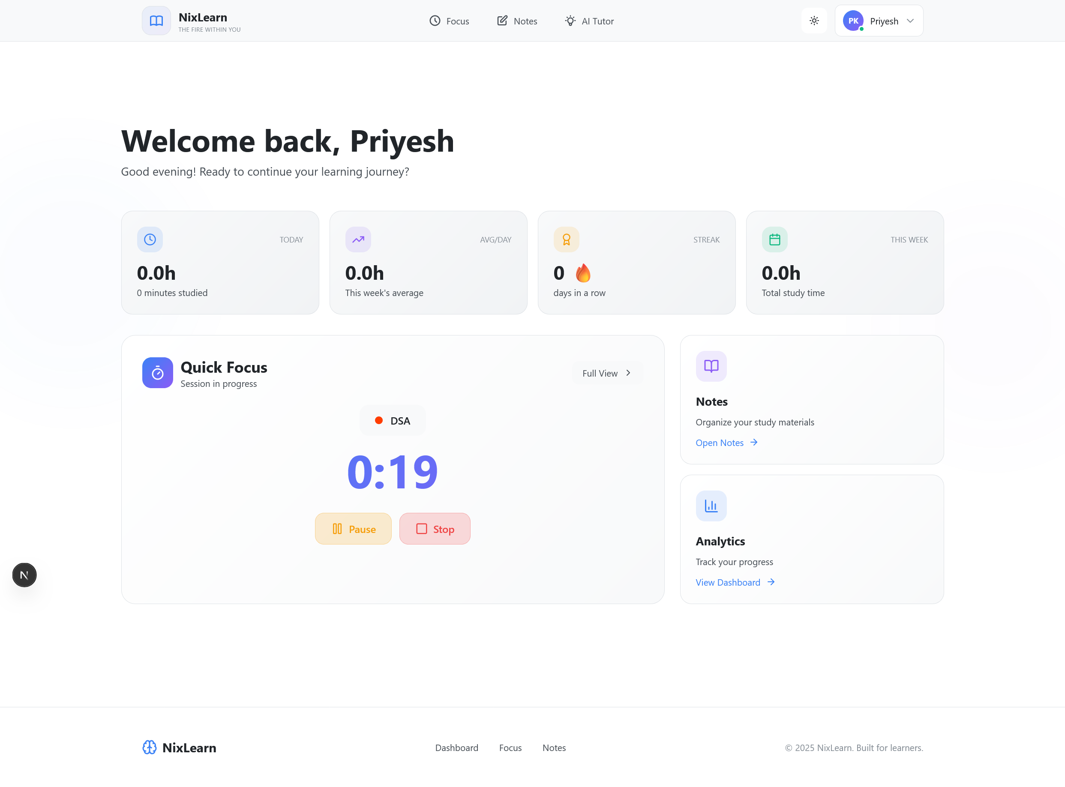

5.2. /focus page
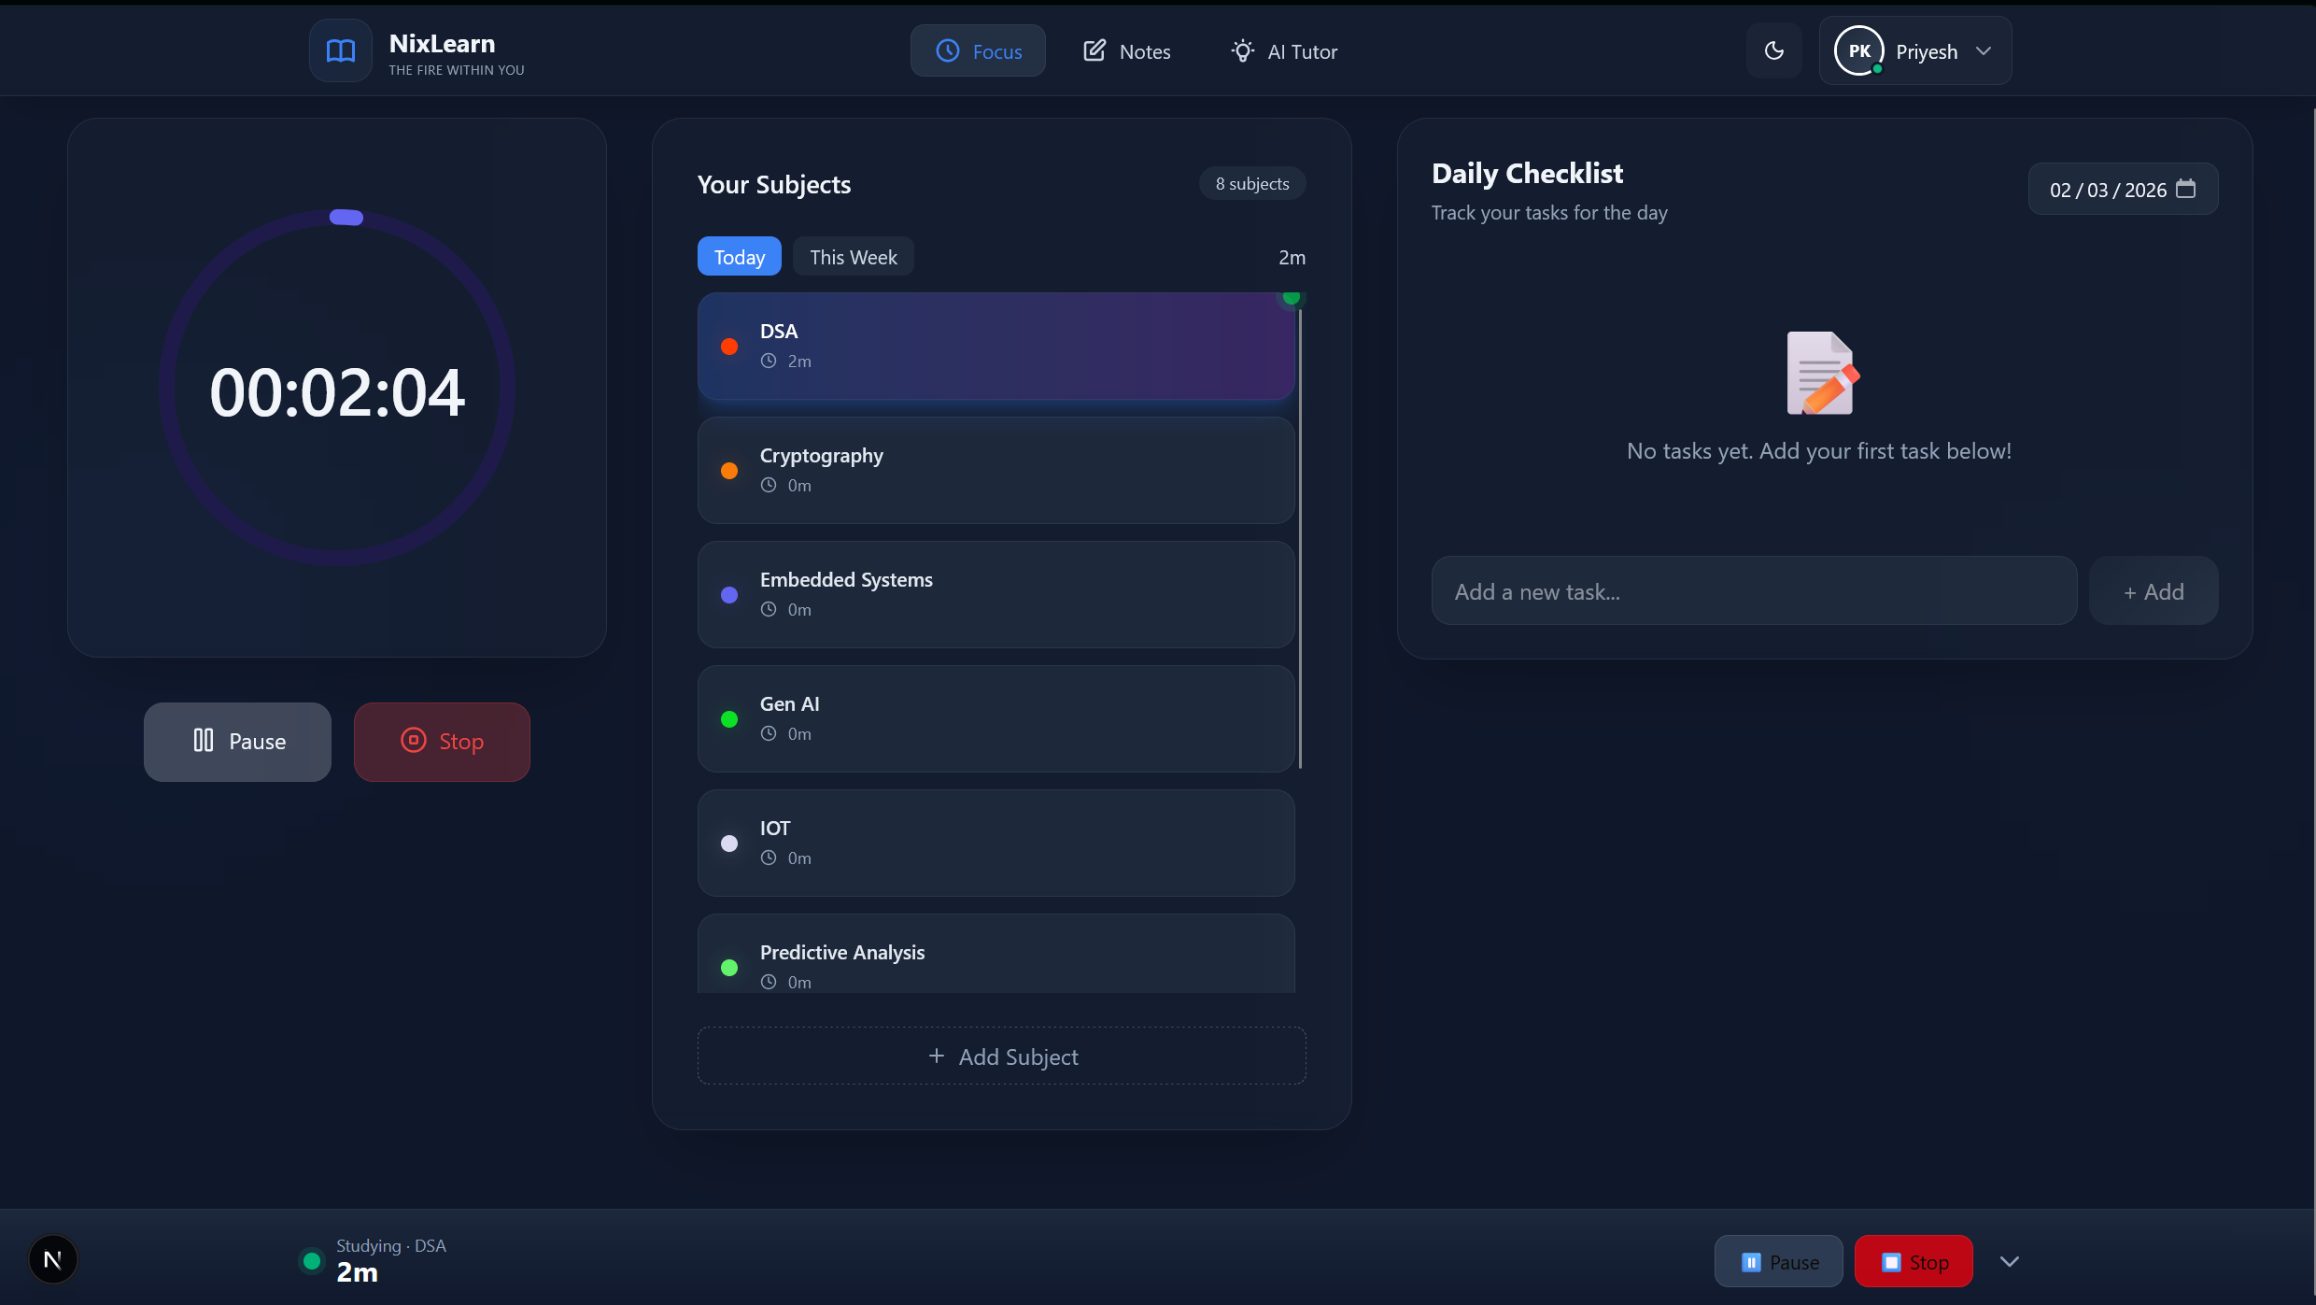
5.3. /notes page
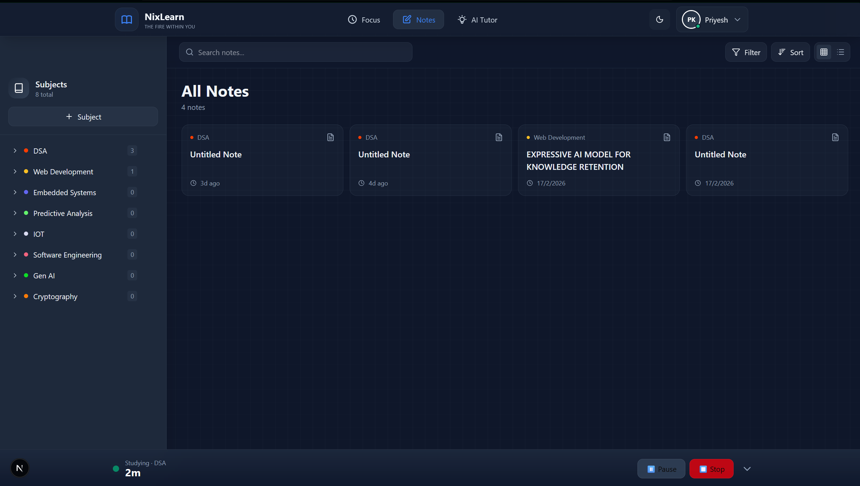

/notes/e27b402c-fa44-4941-890c-e36568d6b302 page
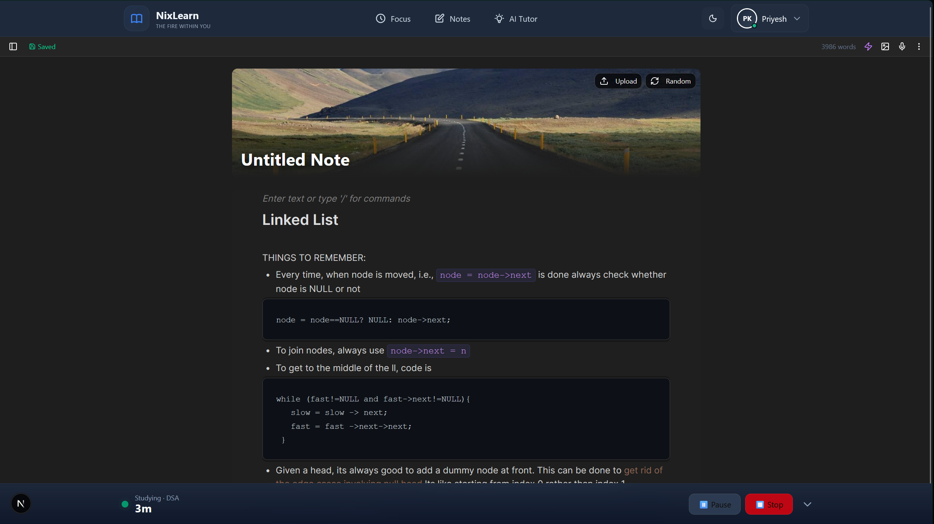

/tutor page
